Dear editor and reviewers,

We thank you for taking the time to read our manuscript and provide helpful comments and suggestions. The comments have been considered, and we believe they have helped improve the structure and the robustness of the manuscript.

EDITORIAL FORMATTING ISSUES

Authors contributions and affiliations have been corrected.

Bibliography

Figures format

Appellation des figures dans text (ex appendices)

SUBJECT EDITOR

…

REVIEWER 1

[1] I understand the rationale for lumping different parasite species together as black spots, however they belong to different families and utilise snail first intermediate hosts also belonging to different families. Parasites and snails may have different tolerances of abiotic conditions, etc. Pooling species (actually, pooling families) is bound to generate spurious patterns. Perhaps this needs to be discussed as a caveat.

We chose this approach for its field work relevance and to maximize the host sample size we could observe. Disregarding, we agree that pooling different parasite families is an unusual approach in the study of host-parasite ecology that comes with many challenges. We developed this issue in the new “Speculations” section acknowledging the overlook of phylogenetics and the need to explore it in future work.

[2] Similarly, focusing on fish community-level prevalence can mask interesting patterns at the fish species level. Would it be possible to repeat the same analyses by focusing only on a single fish species (the one found in highest numbers at most localities, probably pumpkinseeds)?

This is a good point. We decided to focus on fish community-level because of several reasons: 1) black spot trematodes were unidentified and have a low host specificity, 2) community infection prevalence is easier to measure by wildlife manager/technician since you don’t need to target specific fishes, hence the relevance to develop understanding about community-level infection metrics.

That said, we agree that interesting patterns can be masked by the additional complexity that comes with community ecology. For this reason, we executed the three same analyses focusing on species-level, using data on the pumpkinseed sunfish. This is the only species abundant and prevalent (in terms of localities) enough to perform all three analyses. We decided not to incorporate these in the manuscript because we feel they lack statistical power and would considerably increase the length of the manuscript.

For the ***regional-scale analyses*** we can see that landscape prevalence values are more elevated in the species-level plot than in the community-level plot which was expected because the pumpkinseed sunfish has the highest landscape infection prevalence of all fishes sampled (Figure R1). The order in which the methods appear however differed in the species-level plot. This is probably because method-biases are species-specific. Curves also stabilize at smaller sampling efforts in the species-level plot compared to the community-level plot. Regardless, both plots show the same trends with decreasing prevalence value along the sampling gradient, and this is the relationship this analysis aimed to look at.

For the ***lake-scale analyses***, patterns of frequency distributions are different between both biological-scale (Figure R2). However, we have to consider that pumpkinseeds are only present in 11 lakes out of 15 lakes sampled meaning the community-level plot have more data to go on than the species-level plot. All distributions in Figure R2 are left-skewed because pumpkinseeds have a higher infection susceptibly, and potentially, a higher encounter rate with black spot than other species.

For the ***site-scale analyses***, some of the models previously significant at community-level were not at species-level (Figure R3). This is the case for pH, conductivity, macrophyte cover, perimeter, non-host abundance and Simpson’s diversity index models – suggesting that observed patterns at community-level for these predictors do not rely on species-specific mechanisms. All models followed the same trends at both biological level except for the turbidity model (Figure R3.Aa–R3.Ba). Only one model that was found significant at species-level was not at community level (total phosphorus; Figure R3.Ae)

[3] It is unfortunate that prevalence was the only infection metric considered here. The impact of trematode metacercariae on fish is intensity-dependent, therefore measures such as mean intensity or abundance would better reflect spatial variation in the parasites’ impact on host population dynamics. Even if counting the spots on each fish would have been impossible considering the time required, a rough visual estimate (relative scale from 0 to 5, i.e. few to very many black spots) could have been obtained quickly in the field and provided very useful data.

Indeed, other infection metrics such as abundance and intensity would better reflect spatial variation and risk assessment of host-population, but as mentioned, these would be impossible to accurately measure in the field. In truth, we did estimate the intensity of infection on a scale from 1 to 5 for all fishes caught using the fishing methods (i.e., minnow trap and seine net). During snorkeling transects, we did not estimate intensity of infection because identifying fishes, counting them and inspecting individuals for infection already demanded all the observers’ attention. After reflection, we decided not to use the infection intensity data in the current manuscript because we could not compare this data among all sampling methods.

[4] The authors show that low sampling effort overestimates prevalence, with the estimates eventually stabilizing around the ‘true’ value as sampling effort increases (Figure 3). This is a really nice finding. Here, sampling effort is measured as the number of distinct host samples. However, sampling effort can also be measured as the number of individual hosts examined. In the Discussion, the authors allude to this and refer to Jovani & Tella (2006). They may also want to consider a more robust study, that of Gregory & Woolhouse (1993, Acta Tropica 54: 131-139), which suggests the opposite, i.e. that low sampling effort may lead to an underestimate of true prevalence.

A couple of studies have indeed examined the effect of sample size (i.e., the number of hosts) on parasitological parameters such as parasite abundance, infection prevalence or parasite aggregation. From what we understand, conclusions of Gregory and Woolhouse (1993) stipulate that estimates of parasite prevalence were close to the true values and that this did not vary with simple size. Their findings are nevertheless contrasting with our own conclusions. We think this is something worth mentioning.

We added the sentence (L462-463): “Gregory and Woolhouse (1993) found contrasting results where simple size has no effect on prevalence values.”.

[5] Is it possible that the bimodal distribution of prevalence values across lakes (Figure 4) for the transect and combined methods is due to the fact that a snorkeler is more likely to detect infection when fish are heavily infected? So if you have two lakes, one with high intensity of infection and one with low intensity, but both with the same prevalence, visual detection by snorkelers might lead to high and low prevalence estimates, respectively. It’s easier to see 100 black spots on a fish than just two or three spots. Could the bimodal distribution reflect high variance in average intensity of infection among lakes, not in prevalence? The other two methods, where fish are held in the researchers’ hands, are much less likely to produce prevalence estimates affected by low intensity values.

This is an interesting thought we have not considered so far, but might be possible since, as mentioned, snorkeling observations have a higher infection assessment uncertainty. If we consider fishing prevalence as the “true” prevalence (i.e., prevalence measured with data from both minnow traps and sein net) and low-prevalence lakes reporting ≤ 25% of infection, we can compare the “true” prevalence of these lakes to the prevalence obtained through snorkeling observations. In our data, there is 4 lakes fitting these criteria that have been sampled with all three methods (lake Triton was not included because of 0% prevalence measured with any method). Comparison of prevalence measured with either fishing methods (“true prevalence”) or snorkeling transects (Table R1) shows that snorkeling observations underestimated infection prevalence in ¾ lakes with difference in prevalence varying between 8 and 15%. In lake Echo, the snorkeling method led to a prevalence 3% than fishing methods. Therefore, we agree with you reflection but are data doesn’t allow validation of the hypothesis.

For the second part of this comment relating to bimodal distribution reflecting variance in average intensity instead of prevalence, we compared frequency distributions of lake’s prevalence suggesting bimodality (transect and method combination) with frequency distributions of lake’s mean intensity class (mean intensity class estimated with data from both fishing methods – not used in this manuscript) (Figure R4). The data doesn’t show a clear relationship between lake’s prevalence and intensity frequency distributions.

[6] Regarding spatial patterns in hotspots and coldspots of infection by trematodes in fish, the following may be relevant: Blasco-Costa et al (2015) Ecography 38: 301-310  
  
[7] Regarding the environmental (biotic and abiotic) drivers of prevalence, the following may be relevant: Martins & Poulin (2024) Proceedings B 291: 20241673  
  
[8] Lines 188-190: the same sentence is repeated twice.

The repeated sentence has been deleted (L188-189).

[9] Lines 298-304: two of the 15 fish species were excluded from prevalence estimations because the literature suggested they were not suitable hosts. Why not repeat the analysis after excluding the other seven species (by my calculation) that were not found in your survey to be infected at all? Your own data provide some evidence that they may not be suitable hosts as well…

The problem with this is that cyprinids were not identified to the species level during the snorkeling transects. Even though, we tested it excluding uninfected species for the minnow trap and seine net method while excluding all cyprinids for the transect method (cyprinids show none or very low infection levels). We saw minimal differences in the prevalence accumulation curve (conclusions stay the same). Frequency distributions were different when excluding these fish from the prevalence estimation, probably because of the community structure in some lakes thus excluding a lot of individuals. Only null, turbidity, dissolved oxygen, area:perimeter and fish abundance models were significant when excluding muskellunge, brown bullhead and all cyprinids.

[10] Lines 468-469: missing word? “in terms of area and time to ESTIMATE infection prevalence”?

This is correct. We added the missing word “estimate” in line 472.

REVIEWER 2

[11] The authors combine two contributions, the analysis of local determinants of parasites prevalence and the analysis of estimation biases. In a respectful perspective, my opinion is that this duality is not well articulated in the manuscript, with a result that dilutes these contributions rather than complementing and potentiating them. I wonder if the large development of the sampling bias issue should not be toned down here to support for the reported patterns and further develop a focus on the role of biotic and abiotic environments on parasites prevalence. Note that the effect of aggregation on sampling design and statistical analyses, as well as the inherent biases, were extensively considered elsewhere. Of course, the focus of the manuscript is the authors' responsibility, and here I just transmit a respectful reflection.

We are aware that the manuscript articulation and flow are unconventional relating, as mentioned, two different contributions (environmental drivers and sampling biases). The manuscript’s format has been discussed among authors for several months with consideration on choosing either the current format or writing two different manuscripts (one on sampling biases and one on environmental drivers of prevalence). After discussion, we leaned towards the current format because it allows a better overview of the study system and variability involved in field studies. We are of opinion that sampling bias issues addressed here are very important contributing to literature gaps on effect of sampling design on estimation of prevalence. While effect of aggregation and sample size has been addressed before, effect of the number of samplings have never been explored and examination of sampling methods relating to prevalence estimation have not been extensively reported (but see Wilson et al., 1993; Journal of Comparative Psychology). Moreover, this have never been done in the context of community prevalence. We feel that these elements relate to the reality of field studies and surveys, with great contributions in the understanding of sampling design biases and in the planification of field work.

[12] The authors repeatedly highlight some general statements about the complexity of the study system, the dependence of scale on pattern and processes, and the role of different sources of heterogeneity. These properties are common to most, if not all, ecological systems. In this sense, they do not provide a particularly important context for the present contribution. In my opinion, a better framework could be considered.

These are indeed common to most system, but we are of opinion that context-dependencies, while usually acknowledged by the scientific community, are often overlooked or ignored, especially in parasitological ecology where these “common knowledge” are less developed than in other fields in ecology.

[13] In the abstract, the authors alternate between real patterns and their determinants and the sampling issue that does not adequately articulate the two focus. I think this section could be improved with a better order and clear ideas. It is now difficult to easily extract the main contributions of the study. In my opinion, the presentation of both the framework and the specific contribution could be improved.

The idea in the abstract was to follow the order in which analyses are presented in the manuscript (landscape- lake- site-scale). We moved the sentence: “Our results showed that infection prevalence is spatially heterogeneous across the landscape with evidence of infection hotspots and coldspots” further down so it is less confusing (L13-15).

[14] The discussion devotes a great deal of attention to sampling issues, not providing a robust consideration of the theoretical framework and the contributions attained in this research. In addition, it is large and, in my opinion, fails to identify novel contributions over general issues such as individual aggregation and sampling design.

This study was observational, thus not directly test theoretical hypothesis. We could not exactly address aggregation issues and theories because parasite abundance was not measured.

[15] L114-126. I think this is not a good paragraph to close the introduction. It is not clear, it focuses on lateral issues about cold-hot areas and estimation biases, with general comments not fully rooted in statistical grounds. There is a broad and diverse literature on the effect of aggregation in sampling design in ecology and other areas. It is not evident that the study contributes something new in this framework.

We agree this an unusual paragraph to end the introduction. We decided not to present our predictions after all and removed this paragraph. We incorporated a new sentence at the end of the previous paragraph on general contributions of the present study (L119-121).

[16] L164 it is not evident that this represents a random design.

Our field survey was not based on a random design because of land and data accessibility limitations. However, the selected sites display the variability in morphometry, habitat types, and anthropogenic use picturing the regional variability of lakes.

[17] L281 a cubic spline with one variable at a time is producing an overfitting and suggesting more relationships than those that are actually supported by the study.

Using highly flexible models such as GAM(M)s, especially with small sample size, comes with this overfitting risk. Since we needed to include a random effect to account for nested data, we could not have many predictors to our models because it uses too many degrees of freedom. We chose a cubic spline instead of a cubic regression spline or a thin plate spline because i) we did not expect abrupt changes in the relationships between prevalence and environmental drivers, ii) cubic spline offer the smoothest option and offer no computational problems for univariate smoothing and, iii) their computational cost is lower than thin plate spine (that we want to minimize since we have a small sample size)(Wood, 2006; Wood & Augustin, 2002). Moreover, our aim here is not to use these models to make predictions but simply inspect data to better understand how prevalence estimates vary with local environment. We did not find any evidence that using a cubic spline with one variable actually increases the overfitting compared to other smoothers that are appropriate for our data. Nevertheless, we decided to reduce the number of basis function at 5 (k=5) to reduce the computational burden and chance of overfitting (Wood & Augustin, 2002).

[18] Figure 2, this is a nice figure but not particularly informative for the space that will finally be in the published ms.

The figure is indeed quite large and not essential to the understanding. However, since the journal has a wide readership in ecology, we think that this figure is helpful understanding parasite’s complex life cycle and all environmental characteristics that might influence observed patterns.

[19] Figure 3 Presenting the confidence interval for a Loess smooth makes no sense for the present analysis. The confidence interval for 999 resamples must be reported. Indeed, a large interval is expected at lower sampling levels and its reduction with the increase in sampling size. The trend in these intervals (from the true sampling error) is the subject of analysis for the sampling design.

Thank you for this comment. Confidence intervals have been removed on loess smooths. We calculated confidence intervals for each N resampled 999 times. We reported them in Table SX, instead of the Figure X because intervals made the figure messy and hard to read.

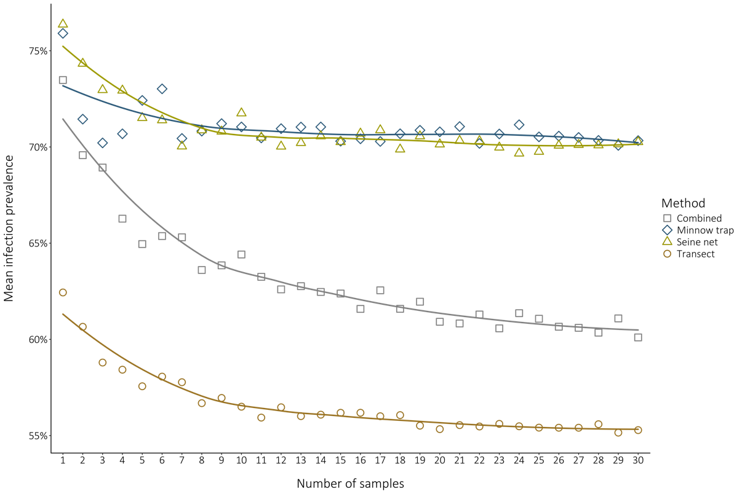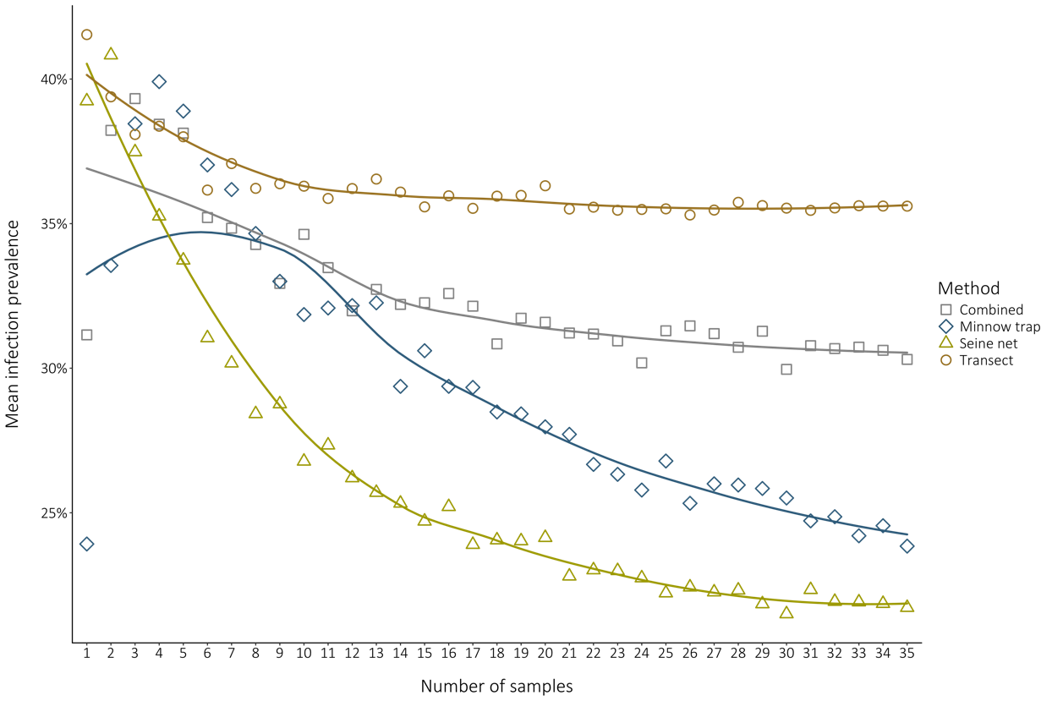

A.

B.

**Figure R1.** Comparison of regional-scale resampled prevalence analysis. **A.** Species-level analysis (on pumpkinseeds data). **B.** Community-level has it was presented in the first submitted version of the manuscript.

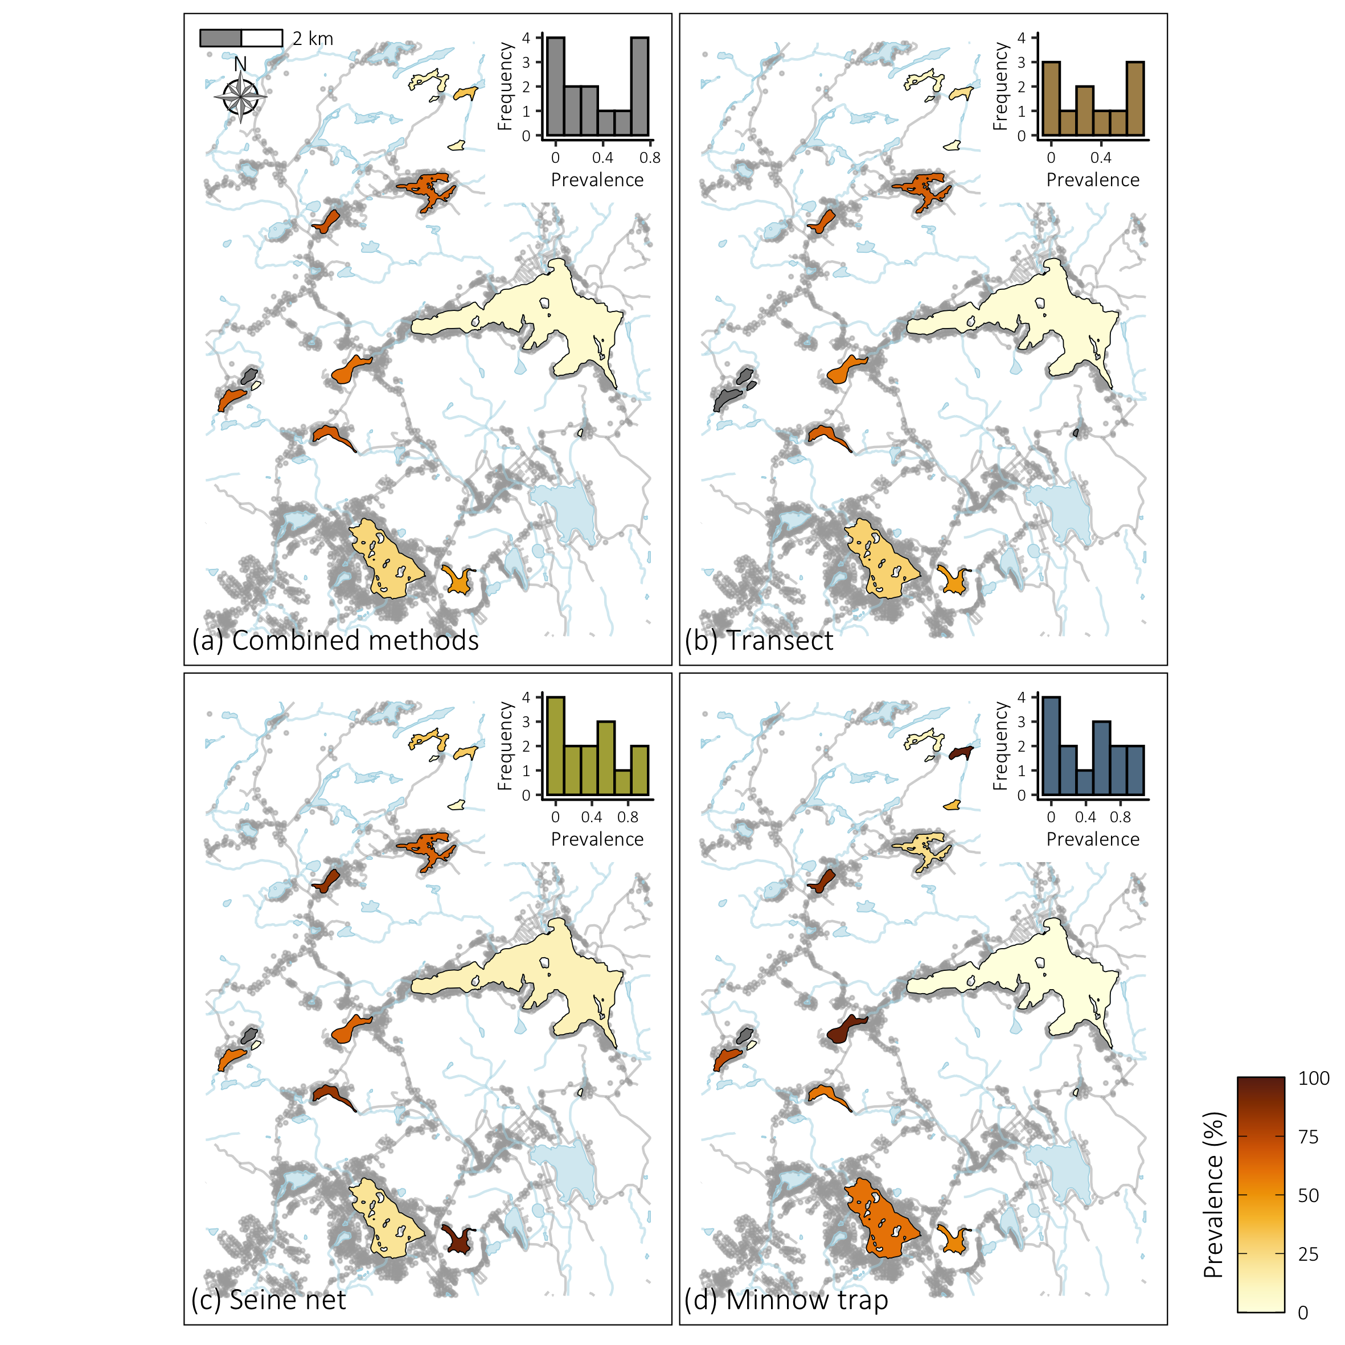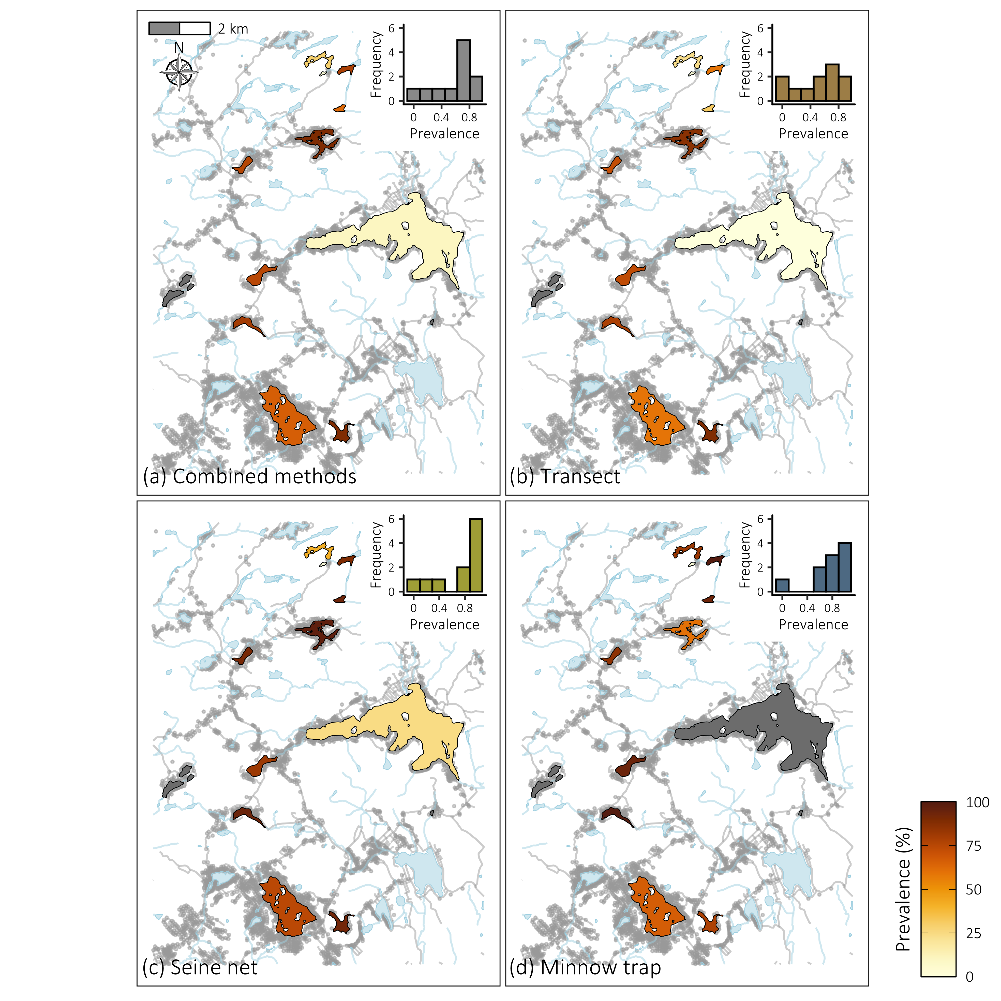

A.

B.

**Figure R2.** Comparison of lake-scale prevalence distribution analysis. **A.** Species-level analysis (on pumpkinseeds data). **B.** Community-level has it was presented in the first submitted version of the manuscript.



A.

B.

**FigureR3.** Comparison of site-scale envrionmental driver analyses. **A.** Species-level analysis (on pumpkinseeds data). **B.** Community-level has it was presented in the first submitted version of the manuscript.

|  |  |  |  |  |
| --- | --- | --- | --- | --- |
| Lakes | Achigan | Corriveau | Croche | Echo |
| Fishing prevalence | 12% | 20% | 18% | 25% |
| Snorkeling prevalence | 3% | 5% | 10% | 28% |
| Difference | 9% | 15% | 8% | -3% |

**Table R1.** Comparison of fishing “true” prevalence with snorkeling prevalence in low-prevalence lakes (≤ 25%).

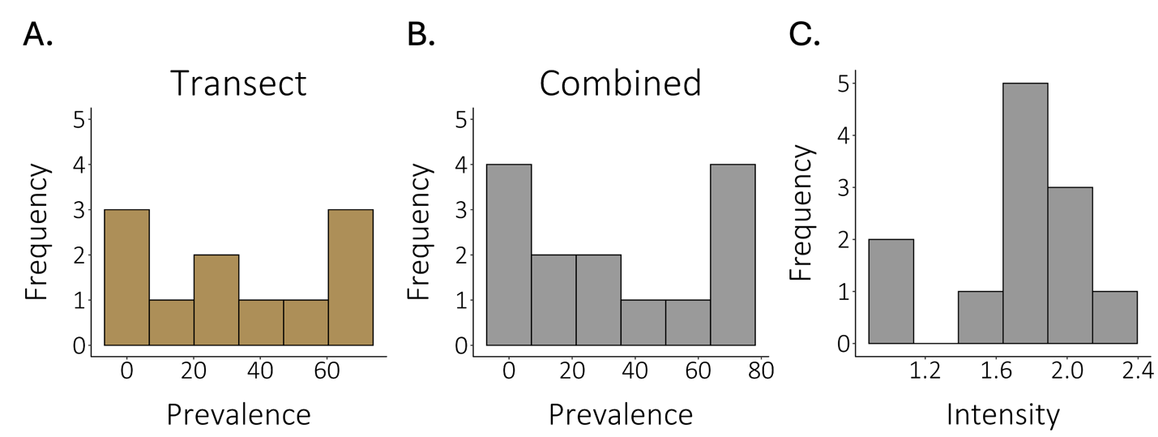

**FigureR4.** Comparison of lake-scale frequency distribution of **A**. Mean infection prevalence in lakes estimated with the snorkeling method, **B.** Mean infection prevalence in lakes estimated with the combined methods, and **C.** Mean infection intensity class in lakes estimated with pooled data from both fishing methods (minnow trap and seine net). Intensity classes range from 1to 5.